Sr No |  | Practical Name | Sign
1 |  | Introduction to TensorFlow
1 | a | • Create tensors with different shapes and data types.  • Perform basic operations like addition, subtraction, multiplication, and division on tensors.  • Reshape, slice, and index tensors to extract specific elements or sections.  • Performing matrix multiplication and finding eigenvectors and eigenvalues using TensorFlow
1 | b | Program to solve the XOR problem.
2 |  | Linear Regression
2 |  | Implement a simple linear regression model using TensorFlow's low level API (or tf. keras).  Train the model on a toy dataset (e.g., housing prices vs. square footage).  Visualize the loss function and the learned linear relationship.  Make predictions on new data points.
3 | a | Implementing deep neural network for performing binary classification task
3 | b | Using a deep feed-forward network with two hidden layers for performing multiclass classification and predicting the class.
4 |  | Write a program to implement deep learning Techniques for image segmentation.
5 |  | Write a program to predict a caption for a sample image using LSTM.
6 |  | Applying the Autoencoder algorithms for encoding real-world data
7 |  | Write a program for character recognition using RNN and compare it with CNN.
8 |  | Write a program to develop autoencoders using MNIST Handwritten Digits.
9 |  | Demonstrate Recurrent Neural Network that learns to perform sequence analysis for stock price. (google stock price)
10 |  | Applying Generative Adversial Networks for image generation and unsupervised tasks.
INDEX

PRACTICAL NO - 01

Aim: Introduction to TensorFlow

Practical 1a:
• Create tensors with different shapes and data types.
• Perform basic operations like addition, subtraction, multiplication, and division on tensors.
• Reshape, slice, and index tensors to extract specific elements or sections.
• Performing matrix multiplication and finding eigenvectors and eigenvalues using TensorFlow

Cmd:
pip install tensorflow

Code:
# =====================================
# TensorFlow Basics â€“ Spyder Compatible
# =====================================

import tensorflow as tf

print("TensorFlow Version:", tf.__version__)

# -----------------------------
# Scalar (0-D Tensor)
# -----------------------------
scalar = tf.constant(10)
print("\nScalar (0-D):", scalar.numpy())

# -----------------------------
# Vector (1-D Tensor)
# -----------------------------
vector = tf.constant([1.0, 2.0, 3.0])
print("\nVector (1-D):", vector.numpy())

# -----------------------------
# Matrix (2-D Tensor)
# -----------------------------
matrix = tf.constant([[1, 2],
[3, 4]])
print("\nMatrix (2-D):")
print(matrix.numpy())

# -----------------------------
# 3-D Tensor
# -----------------------------
tensor3d = tf.constant([
[[1, 2], [3, 4]],
[[5, 6], [7, 8]]
])
print("\nTensor (3-D):")
print(tensor3d.numpy())

# -----------------------------
# Float Tensor
# -----------------------------
float_tensor = tf.constant([1.1, 2.2, 3.3], dtype=tf.float32)
print("\nFloat32 Tensor:", float_tensor.numpy())

# -----------------------------
# String Tensor
# -----------------------------
string_tensor = tf.constant(["Hello", "TensorFlow"])
print("\nString Tensor:", string_tensor.numpy())

# -----------------------------
# Boolean Tensor
# -----------------------------
bool_tensor = tf.constant([True, False, True])
print("\nBoolean Tensor:", bool_tensor.numpy())

# -----------------------------
# Shape and Data Type
# -----------------------------
print("\nShape of 3D Tensor:", tensor3d.shape)
print("Data Type of 3D Tensor:", tensor3d.dtype)

# -----------------------------
# Arithmetic Operations
# -----------------------------
a = tf.constant([10, 20, 30])
b = tf.constant([1, 2, 3])

print("\nAddition:", tf.add(a, b).numpy())
print("Subtraction:", tf.subtract(a, b).numpy())
print("Multiplication:", tf.multiply(a, b).numpy())
print("Division:", tf.divide(a, b).numpy())
print("Square of a:", tf.square(a).numpy())

# -----------------------------
# Reshape Operations
# -----------------------------
tensor = tf.constant([
[1, 2, 3],
[4, 5, 6],
[7, 8, 9]
])

print("\nOriginal Tensor:")
print(tensor.numpy())

print("\nReshaped to 1D:")
print(tf.reshape(tensor, [-1]).numpy())

print("\nReshaped to (1, 9):")
print(tf.reshape(tensor, [1, 9]).numpy())

print("\nReshaped to (9, 1):")
print(tf.reshape(tensor, [9, 1]).numpy())

# -----------------------------
# Indexing and Slicing
# -----------------------------
print("\nElement at position [1,2]:", tensor[1, 2].numpy())
print("Second Row:", tensor[1].numpy())
print("First Two Columns:")
print(tensor[:, :2].numpy())
print("Bottom-right 2x2:")
print(tensor[1:, 1:].numpy())

# -----------------------------
# Matrix Multiplication
# -----------------------------
A = tf.constant([[4., 2.],
[1., 3.]])

B = tf.constant([[1., 0.],
[0., 1.]])

print("\nMatrix A:")
print(A.numpy())

print("\nMatrix B:")
print(B.numpy())

print("\nMatrix Multiplication (A x B):")
print(tf.matmul(A, B).numpy())

# -----------------------------
# Eigenvalues and Eigenvectors
# -----------------------------
eigenvalues, eigenvectors = tf.linalg.eig(A)

print("\nEigenvalues:")
print(eigenvalues.numpy())

print("\nEigenvectors:")
print(eigenvectors.numpy())

Output:

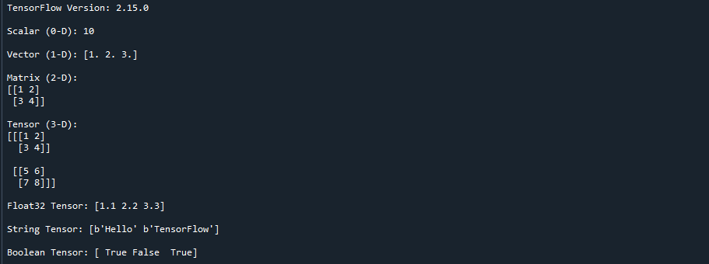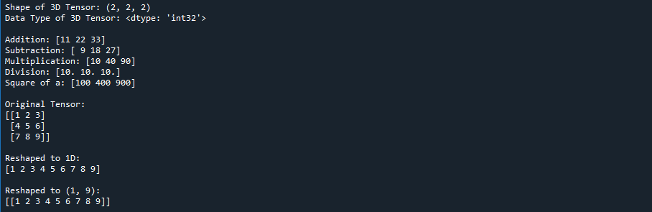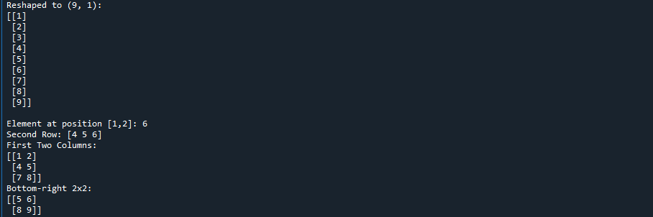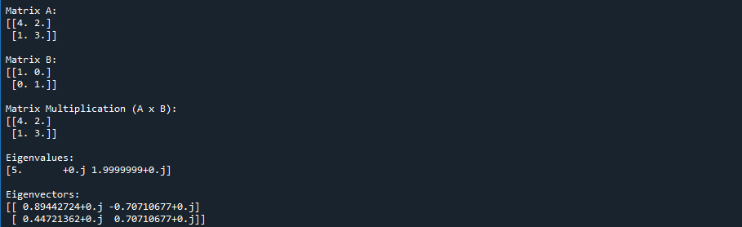

Practical 1b: Program to solve the XOR problem.

Code:
import os
os.environ['TF_CPP_MIN_LOG_LEVEL'] = '2' # Hide TF info messages

import numpy as np
import tensorflow as tf
from tensorflow.keras.models import Sequential
from tensorflow.keras.layers import Dense, Input

# -----------------------------
# XOR Dataset
# -----------------------------
X = np.array([[0, 0],
[0, 1],
[1, 0],
[1, 1]])

y = np.array([[0],
[1],
[1],
[0]])

# -----------------------------
# Model Definition
# -----------------------------
model = Sequential([
Input(shape=(2,)), # Input layer (2 features)
Dense(4, activation='relu'), # Hidden layer
Dense(1, activation='sigmoid') # Output layer
])

# -----------------------------
# Compile Model
# -----------------------------
model.compile(
optimizer='adam',
loss='binary_crossentropy',
metrics=['accuracy']
)

# -----------------------------
# Train Model
# -----------------------------
model.fit(X, y, epochs=1000, verbose=0)

# -----------------------------
# Prediction
# -----------------------------
predictions = model.predict(X)

print("Predictions (rounded):")
print(np.round(predictions))

Output:

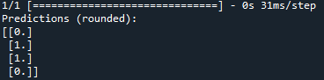

PRACTICAL NO – 02

Aim: Linear Regression
Implement a simple linear regression model using TensorFlow's low level API (or tf. keras).
Train the model on a toy dataset (e.g., housing prices vs. square footage).
Visualize the loss function and the learned linear relationship.
Make predictions on new data points.

Code:
import tensorflow as tf
import numpy as np
import matplotlib.pyplot as plt

# -----------------------------
# Dataset
# -----------------------------
X_train = np.array([500, 750, 1000, 1250, 1500, 1750, 2000], dtype=np.float32)
Y_train = np.array([150, 200, 250, 300, 350, 400, 450], dtype=np.float32)

# Compute mean and std for normalization
X_mean, X_std = np.mean(X_train), np.std(X_train)
Y_mean, Y_std = np.mean(Y_train), np.std(Y_train)

# Normalize training data
X = (X_train - X_mean) / X_std
Y = (Y_train - Y_mean) / Y_std

# -----------------------------
# Initialize weight and bias
# -----------------------------
W = tf.Variable(np.random.randn(), dtype=tf.float32)
b = tf.Variable(np.random.randn(), dtype=tf.float32)

# -----------------------------
# Learning rate and optimizer
# -----------------------------
learning_rate = 0.01
optimizer = tf.optimizers.SGD(learning_rate)

# -----------------------------
# Model
# -----------------------------
def predict(x):
return W * x + b

# -----------------------------
# Loss function (MSE)
# -----------------------------
def compute_loss(y_true, y_pred):
return tf.reduce_mean(tf.square(y_true - y_pred))

# -----------------------------
# Training loop
# -----------------------------
loss_history = []

for epoch in range(100):
with tf.GradientTape() as tape:
y_pred = predict(X)
loss = compute_loss(Y, y_pred)
dW, db = tape.gradient(loss, [W, b])
optimizer.apply_gradients(zip([dW, db], [W, b]))
loss_history.append(loss.numpy())

if epoch % 10 == 0:
print(f"Epoch {epoch}: Loss = {loss.numpy():.4f}, W = {W.numpy():.4f}, b = {b.numpy():.4f}")

# -----------------------------
# Visualize Loss Curve
# -----------------------------
plt.figure(figsize=(10, 4))
plt.plot(loss_history, label="Loss")
plt.xlabel("Epoch")
plt.ylabel("MSE Loss")
plt.title("Loss Curve")
plt.legend()
plt.grid(True)
plt.show()

# -----------------------------
# Visualize Learned Line
# -----------------------------
plt.figure(figsize=(10, 5))
plt.scatter(X, Y, color="blue", label="Data")
plt.plot(X, predict(X), color="red", label="Predicted Line")
plt.xlabel("Normalized Square Footage")
plt.ylabel("Normalized Price")
plt.title("Linear Regression Fit")
plt.legend()
plt.grid(True)
plt.show()

# -----------------------------
# Make Predictions (correct normalization)
# -----------------------------
new_sqft = np.array([1800, 2200], dtype=np.float32)
new_sqft_norm = (new_sqft - X_mean) / X_std # Use training mean & std
predicted_price_norm = predict(new_sqft_norm)

# Optional: Convert back to original scale
predicted_price = predicted_price_norm * Y_std + Y_mean

print("Predictions:")
for sqft, price in zip(new_sqft, predicted_price):
print(f"SqFt: {sqft} => Predicted Price: {price:.2f}")

Output:

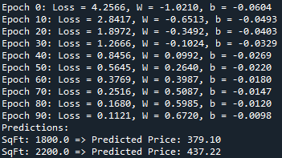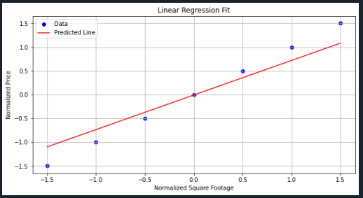

PRACTICAL NO - 03

Aim:

Practical 3A: Implementing deep neural network for performing binary classification task

Code:
# ======================================
# Binary Classification using DNN - Full Working Code
# ======================================

# Step 1: Import necessary libraries
import numpy as np
import pandas as pd
import matplotlib.pyplot as plt
from sklearn.model_selection import train_test_split
from sklearn.preprocessing import StandardScaler
from sklearn.metrics import classification_report, confusion_matrix
import tensorflow as tf
from tensorflow.keras.models import Sequential
from tensorflow.keras.layers import Dense

# Step 2: Generate dummy binary classification data
from sklearn.datasets import make_classification

X, y = make_classification(n_samples=1000, n_features=20, n_classes=2,
n_informative=15, n_redundant=5, random_state=42)

# Step 3: Train-test split (80% train, 20% test)
X_train, X_test, y_train, y_test = train_test_split(X, y, test_size=0.2, random_state=42)

# Step 4: Feature Scaling
scaler = StandardScaler()
X_train = scaler.fit_transform(X_train)
X_test = scaler.transform(X_test)

# Step 5: Define the Deep Neural Network model
model = Sequential([
Dense(64, input_dim=20, activation='relu'), # First hidden layer
Dense(32, activation='relu'), # Second hidden layer
Dense(16, activation='relu'), # Third hidden layer
Dense(1, activation='sigmoid') # Output layer for binary classification
])

# Step 6: Compile the model
model.compile(loss='binary_crossentropy', optimizer='adam', metrics=['accuracy'])

# Step 7: Train the model
history = model.fit(X_train, y_train, epochs=50, batch_size=16, validation_split=0.2, verbose=1)

# Step 8: Evaluate the model on test data
loss, accuracy = model.evaluate(X_test, y_test)
print(f"\nTest Accuracy: {accuracy * 100:.2f}%")

# Step 9: Make predictions and display evaluation metrics
y_pred_prob = model.predict(X_test)
y_pred = (y_pred_prob > 0.5).astype("int32")

print("\nConfusion Matrix:")
print(confusion_matrix(y_test, y_pred))

print("\nClassification Report:")
print(classification_report(y_test, y_pred))

# Step 10: Plot Accuracy and Loss Curves
plt.figure(figsize=(12, 5))

# Accuracy plot
plt.subplot(1, 2, 1)
plt.plot(history.history['accuracy'], label='Train Accuracy')
plt.plot(history.history['val_accuracy'], label='Validation Accuracy')
plt.title('Model Accuracy')
plt.xlabel('Epoch')
plt.ylabel('Accuracy')
plt.legend()
plt.grid(True)

# Loss plot
plt.subplot(1, 2, 2)
plt.plot(history.history['loss'], label='Train Loss')
plt.plot(history.history['val_loss'], label='Validation Loss')
plt.title('Model Loss')
plt.xlabel('Epoch')
plt.ylabel('Loss')
plt.legend()
plt.grid(True)

plt.tight_layout()
plt.show()

Output:

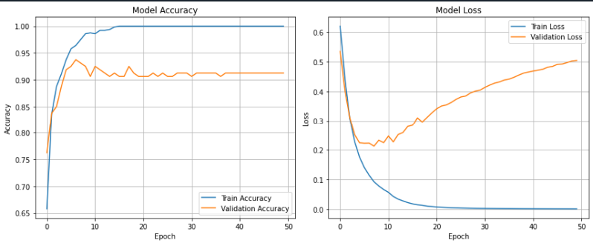
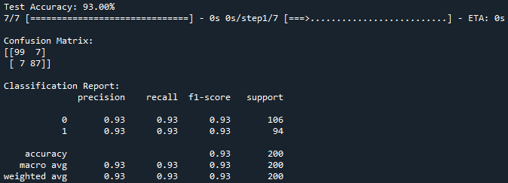

Practical 3b: Using a deep feed-forward network with two hidden layers for performing multiclass classification and predicting the class.

Code:
# ======================================
# Iris Dataset Classification using DNN
# ======================================

# Step 1: Import libraries
import numpy as np
import matplotlib.pyplot as plt
from sklearn.datasets import load_iris
from sklearn.model_selection import train_test_split
from sklearn.preprocessing import StandardScaler, LabelBinarizer
from sklearn.metrics import classification_report, confusion_matrix
import tensorflow as tf
from tensorflow.keras.models import Sequential
from tensorflow.keras.layers import Dense

# Step 2: Load the Iris dataset
iris = load_iris()
X = iris.data # Features: sepal/petal length & width
y = iris.target # Target: 0,1,2 (species)

# Step 3: One-hot encode the labels for multi-class classification
encoder = LabelBinarizer()
y = encoder.fit_transform(y)

# Step 4: Split data into train and test sets
X_train, X_test, y_train, y_test = train_test_split(
X, y, test_size=0.2, random_state=42
)

# Step 5: Feature scaling (standardization)
scaler = StandardScaler()
X_train = scaler.fit_transform(X_train)
X_test = scaler.transform(X_test)

# Step 6: Define the DNN model
model = Sequential([
Dense(64, input_dim=4, activation='relu'), # Hidden layer 1
Dense(32, activation='relu'), # Hidden layer 2
Dense(3, activation='softmax') # Output layer for 3 classes
])

# Step 7: Compile the model
model.compile(
optimizer='adam',
loss='categorical_crossentropy',
metrics=['accuracy']
)

# Step 8: Train the model
history = model.fit(
X_train, y_train,
epochs=100,
batch_size=8,
validation_split=0.2,
verbose=1
)

# Step 9: Evaluate the model on test data
loss, accuracy = model.evaluate(X_test, y_test)
print(f"\nTest Accuracy: {accuracy * 100:.2f}%")

# Step 10: Make predictions on test data
y_pred_prob = model.predict(X_test)
y_pred_classes = np.argmax(y_pred_prob, axis=1)
y_true = np.argmax(y_test, axis=1)

# Step 11: Confusion matrix and classification report
print("\nConfusion Matrix:")
print(confusion_matrix(y_true, y_pred_classes))

print("\nClassification Report:")
print(classification_report(y_true, y_pred_classes))

# Step 12: Plot training history (accuracy & loss)
plt.figure(figsize=(12, 5))

# Accuracy plot
plt.subplot(1, 2, 1)
plt.plot(history.history['accuracy'], label='Train Accuracy')
plt.plot(history.history['val_accuracy'], label='Validation Accuracy')
plt.title('Model Accuracy')
plt.xlabel('Epochs')
plt.ylabel('Accuracy')
plt.legend()
plt.grid(True)

# Loss plot
plt.subplot(1, 2, 2)
plt.plot(history.history['loss'], label='Train Loss')
plt.plot(history.history['val_loss'], label='Validation Loss')
plt.title('Model Loss')
plt.xlabel('Epochs')
plt.ylabel('Loss')
plt.legend()
plt.grid(True)

plt.tight_layout()
plt.show()

Output:
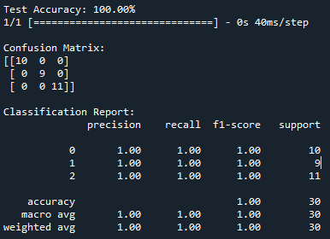
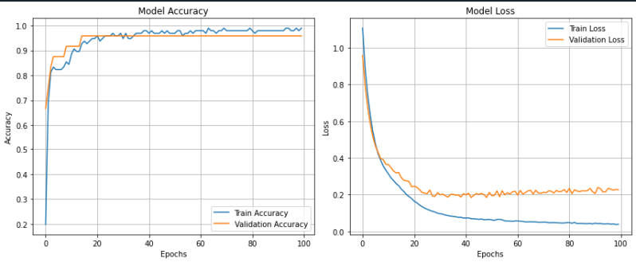

PRACTICAL NO - 04

Aim: Write a program to implement deep learning Techniques for image segmentation.

Code:
# ============================================
# Lightweight U-Net for Image Segmentation
# Oxford-IIIT Pet Dataset
# ============================================

# Step 1: Import required libraries
import tensorflow as tf
import tensorflow_datasets as tfds
import matplotlib.pyplot as plt
import numpy as np
from tensorflow.keras import layers, Model

print("TensorFlow version:", tf.__version__)

# --------------------------------------------
# Step 2: Preprocessing functions
# --------------------------------------------
def normalize(input_image, input_mask):
input_image = tf.cast(input_image, tf.float32) / 255.0
input_mask = tf.cast(input_mask, tf.int32)
input_mask -= 1
return input_image, input_mask

def load_data(datapoint):
input_image = tf.image.resize(datapoint['image'], (64, 64))
input_mask = tf.image.resize(datapoint['segmentation_mask'], (64, 64))
return normalize(input_image, input_mask)

# --------------------------------------------
# Step 3: Load Dataset
# --------------------------------------------
dataset, info = tfds.load(
'oxford_iiit_pet',
with_info=True
)

train_ds = (
dataset['train']
.map(load_data)
.take(100)
.cache()
.batch(8)
.prefetch(tf.data.AUTOTUNE)
)

test_ds = (
dataset['test']
.map(load_data)
.take(20)
.batch(8)
)

# --------------------------------------------
# Step 4: Lightweight U-Net Model
# --------------------------------------------
def fast_unet(output_channels):
inputs = layers.Input(shape=(64, 64, 3))

# Encoder
x1 = layers.Conv2D(32, 3, activation='relu', padding='same')(inputs)
p1 = layers.MaxPooling2D()(x1) # 32x32

x2 = layers.Conv2D(64, 3, activation='relu', padding='same')(p1)
p2 = layers.MaxPooling2D()(x2) # 16x16

# Bottleneck
b = layers.Conv2D(128, 3, activation='relu', padding='same')(p2)

# Decoder
u1 = layers.UpSampling2D()(b)
u1 = layers.Concatenate()([u1, x2])
x3 = layers.Conv2D(64, 3, activation='relu', padding='same')(u1)

u2 = layers.UpSampling2D()(x3)
u2 = layers.Concatenate()([u2, x1])
x4 = layers.Conv2D(32, 3, activation='relu', padding='same')(u2)

outputs = layers.Conv2D(output_channels, 1, activation='softmax')(x4)

return Model(inputs=inputs, outputs=outputs)

# --------------------------------------------
# Step 5: Compile and Train
# --------------------------------------------
OUTPUT_CLASSES = 3

model = fast_unet(OUTPUT_CLASSES)
model.compile(
optimizer='adam',
loss='sparse_categorical_crossentropy',
metrics=['accuracy']
)

model.summary()

model.fit(
train_ds,
epochs=2,
validation_data=test_ds
)

# --------------------------------------------
# Step 6: Visualization Functions
# --------------------------------------------
def display(display_list):
plt.figure(figsize=(12, 4))
title = ['Input Image', 'True Mask', 'Predicted Mask']

for i in range(len(display_list)):
plt.subplot(1, len(display_list), i + 1)
plt.title(title[i])
plt.imshow(tf.keras.utils.array_to_img(display_list[i]))
plt.axis('off')

plt.show()

def create_mask(pred_mask):
pred_mask = tf.argmax(pred_mask, axis=-1)
pred_mask = pred_mask[..., tf.newaxis]
return pred_mask[0]

def show_predictions(dataset, num=1):
for image, mask in dataset.take(num):
pred = model.predict(image)
display([image[0], mask[0], create_mask(pred)])

# --------------------------------------------
# Step 7: Display Sample Prediction
# --------------------------------------------
show_predictions(test_ds, 1)

Output:

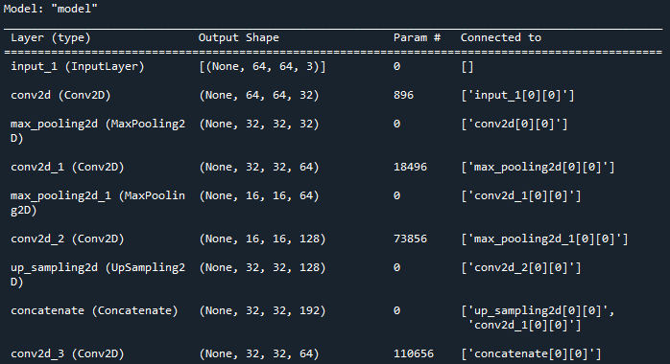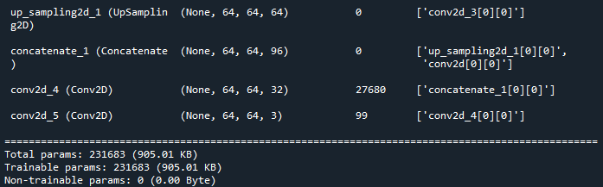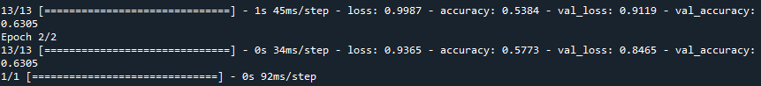
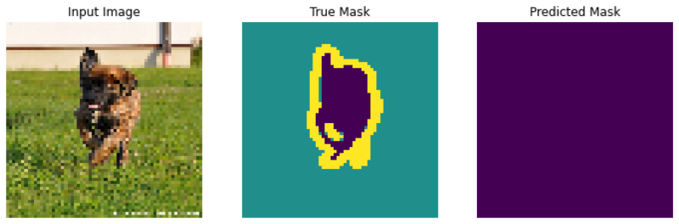

PRACTICAL NO - 05

Aim: Write a program to predict a caption for a sample image using LSTM.

Code:
import tensorflow as tf
import numpy as np
import matplotlib.pyplot as plt
import requests
from io import BytesIO
from PIL import Image

from tensorflow.keras.applications.inception_v3 import InceptionV3, preprocess_input
from tensorflow.keras.preprocessing import image
from tensorflow.keras.models import Model

print("TensorFlow version:", tf.__version__)

# ----------------------------------
# Load and preprocess image from URL
# ----------------------------------
def load_image(url):
response = requests.get(url)
img = Image.open(BytesIO(response.content)).convert("RGB").resize((299, 299))

# Display image
plt.figure(figsize=(4, 4))
plt.imshow(img)
plt.axis('off')
plt.title("Sample Image")
plt.show()

img_array = image.img_to_array(img)
img_array = np.expand_dims(img_array, axis=0)
img_array = preprocess_input(img_array)

return img_array

# Image URL
img_url = "https://tensorflow.org/images/surf.jpg"
img_input = load_image(img_url)

# ----------------------------------
# Load InceptionV3 model
# ----------------------------------
inception = InceptionV3(weights='imagenet')

# Feature extractor (2048 features)
cnn_encoder = Model(
inputs=inception.input,
outputs=inception.layers[-2].output
)

# Extract features
img_features = cnn_encoder.predict(img_input)

# ----------------------------------
# Dummy caption generator
# ----------------------------------
def dummy_caption_generator(features):
return "a man is surfing on the wave"

# Generate caption
caption = dummy_caption_generator(img_features)

print("\n📷 Predicted Caption:")
print(caption)

Output:


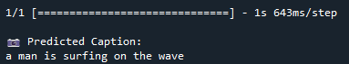

PRACTICAL NO - 06

Aim: Applying the Autoencoder algorithms for encoding real-world data

Code:
import tensorflow as tf
import numpy as np
import matplotlib.pyplot as plt
from tensorflow.keras import layers, models

print("TensorFlow version:", tf.__version__)

# ----------------------------------
# Load Fashion MNIST dataset
# ----------------------------------
(x_train, _), (x_test, _) = tf.keras.datasets.fashion_mnist.load_data()

# Normalize
x_train = x_train.astype("float32") / 255.0
x_test = x_test.astype("float32") / 255.0

# Reshape for CNN
x_train = np.reshape(x_train, (len(x_train), 28, 28, 1))
x_test = np.reshape(x_test, (len(x_test), 28, 28, 1))

# ----------------------------------
# Build Autoencoder Model
# ----------------------------------
def build_autoencoder():
input_img = layers.Input(shape=(28, 28, 1))

# Encoder
x = layers.Conv2D(16, (3, 3), activation='relu', padding='same')(input_img)
x = layers.MaxPooling2D((2, 2), padding='same')(x)
x = layers.Conv2D(8, (3, 3), activation='relu', padding='same')(x)
encoded = layers.MaxPooling2D((2, 2), padding='same')(x)

# Decoder
x = layers.Conv2D(8, (3, 3), activation='relu', padding='same')(encoded)
x = layers.UpSampling2D((2, 2))(x)
x = layers.Conv2D(16, (3, 3), activation='relu', padding='same')(x)
x = layers.UpSampling2D((2, 2))(x)
decoded = layers.Conv2D(1, (3, 3), activation='sigmoid', padding='same')(x)

autoencoder = models.Model(input_img, decoded)
return autoencoder

autoencoder = build_autoencoder()
autoencoder.compile(optimizer='adam', loss='binary_crossentropy')

autoencoder.summary()

# ----------------------------------
# Train Autoencoder
# ----------------------------------
autoencoder.fit(
x_train,
x_train,
epochs=5,
batch_size=128,
shuffle=True,
validation_data=(x_test, x_test)
)

# ----------------------------------
# Predict reconstructed images
# ----------------------------------
decoded_imgs = autoencoder.predict(x_test[:10])

# ----------------------------------
# Display original vs reconstructed
# ----------------------------------
n = 10
plt.figure(figsize=(20, 4))

for i in range(n):
# Original
ax = plt.subplot(2, n, i + 1)
plt.imshow(x_test[i].reshape(28, 28), cmap='gray')
plt.title("Original")
plt.axis('off')

# Reconstructed
ax = plt.subplot(2, n, i + 1 + n)
plt.imshow(decoded_imgs[i].reshape(28, 28), cmap='gray')
plt.title("Reconstructed")
plt.axis('off')

plt.tight_layout()
plt.show()

Output:

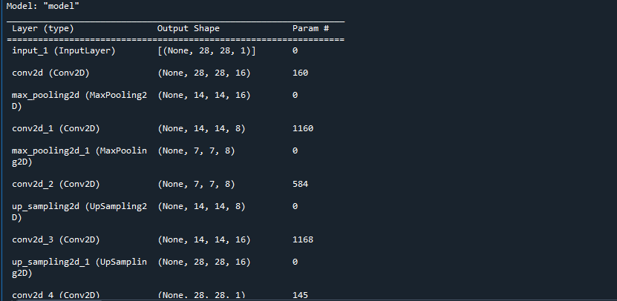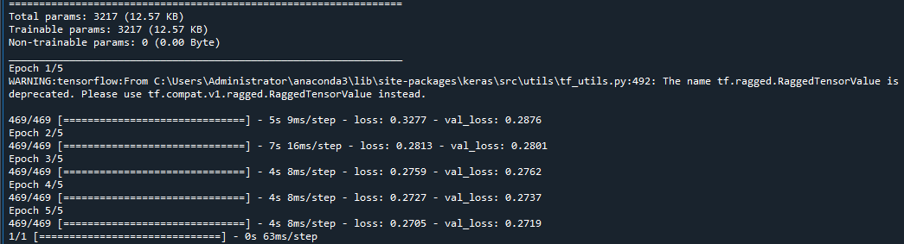
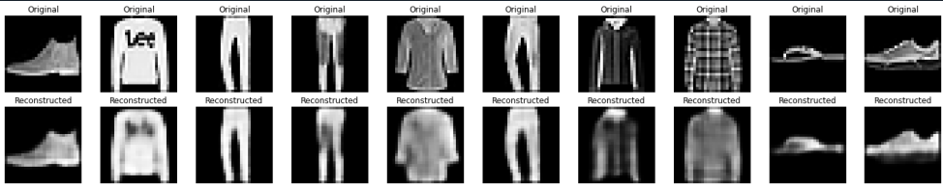

PRACTICAL NO – 07

Aim: Write a program for character recognition using RNN and compare it with CNN.

Code:
# -*- coding: utf-8 -*-
"""
Created on Wed Feb 4 11:23:07 2026

@author: Administrator
"""

import tensorflow as tf
import tensorflow_datasets as tfds
import numpy as np
import matplotlib.pyplot as plt

print("TensorFlow version:", tf.__version__)

# ----------------------------------
# Load EMNIST Letters dataset
# ----------------------------------
(ds_train, ds_test), ds_info = tfds.load(
'emnist/letters',
split=['train', 'test'],
shuffle_files=True,
as_supervised=True,
with_info=True
)

# ----------------------------------
# Preprocess dataset
# ----------------------------------
def normalize_img(image, label):
image = tf.cast(image, tf.float32) / 255.0
image = tf.reshape(image, (28, 28, 1))
label = label - 1 # Convert labels 1–26 to 0–25
return image, label

ds_train = (
ds_train
.map(normalize_img)
.cache()
.shuffle(1000)
.batch(128)
.prefetch(tf.data.AUTOTUNE)
)

ds_test = (
ds_test
.map(normalize_img)
.batch(128)
.cache()
.prefetch(tf.data.AUTOTUNE)
)

# ----------------------------------
# RNN Model
# ----------------------------------
def build_rnn_model():
model = tf.keras.models.Sequential([
tf.keras.layers.Reshape((28, 28), input_shape=(28, 28, 1)),
tf.keras.layers.SimpleRNN(128, activation='tanh'),
tf.keras.layers.Dense(64, activation='relu'),
tf.keras.layers.Dense(26, activation='softmax')
])
model.compile(
optimizer='adam',
loss='sparse_categorical_crossentropy',
metrics=['accuracy']
)
return model

# ----------------------------------
# CNN Model
# ----------------------------------
def build_cnn_model():
model = tf.keras.models.Sequential([
tf.keras.layers.Conv2D(32, (3, 3), activation='relu',
input_shape=(28, 28, 1)),
tf.keras.layers.MaxPooling2D(),
tf.keras.layers.Conv2D(64, (3, 3), activation='relu'),
tf.keras.layers.MaxPooling2D(),
tf.keras.layers.Flatten(),
tf.keras.layers.Dense(128, activation='relu'),
tf.keras.layers.Dense(26, activation='softmax')
])
model.compile(
optimizer='adam',
loss='sparse_categorical_crossentropy',
metrics=['accuracy']
)
return model

# ----------------------------------
# Train Models
# ----------------------------------
rnn_model = build_rnn_model()
cnn_model = build_cnn_model()

print("\n📘 Training RNN model...")
rnn_history = rnn_model.fit(
ds_train,
epochs=3,
validation_data=ds_test
)

print("\n📗 Training CNN model...")
cnn_history = cnn_model.fit(
ds_train,
epochs=3,
validation_data=ds_test
)

# ----------------------------------
# Evaluate Models
# ----------------------------------
rnn_loss, rnn_acc = rnn_model.evaluate(ds_test)
cnn_loss, cnn_acc = cnn_model.evaluate(ds_test)

print("\n✅ Final Accuracy Comparison:")
print(f"RNN Accuracy : {rnn_acc * 100:.2f}%")
print(f"CNN Accuracy : {cnn_acc * 100:.2f}%")

# ----------------------------------
# Plot Validation Accuracy
# ----------------------------------
plt.figure(figsize=(8, 5))
plt.plot(rnn_history.history['val_accuracy'], label='RNN Validation Accuracy')
plt.plot(cnn_history.history['val_accuracy'], label='CNN Validation Accuracy')
plt.title('Validation Accuracy Comparison (EMNIST)')
plt.xlabel('Epoch')
plt.ylabel('Accuracy')
plt.legend()
plt.grid(True)
plt.show()

Output:

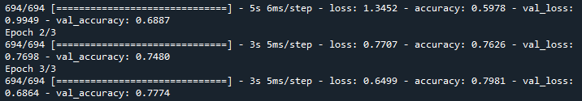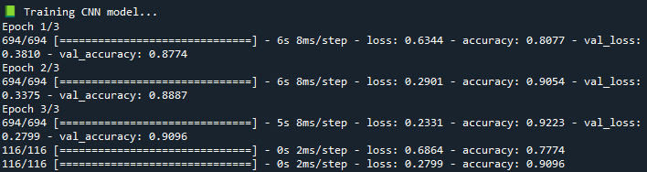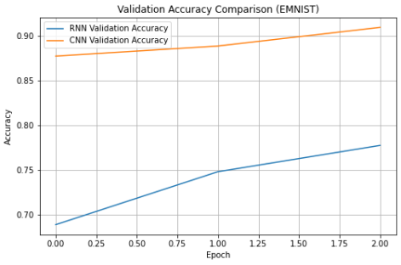

PRACTICAL NO – 08

Aim: Write a program to develop autoencoders using MNIST Handwritten Digits.

Code:
import numpy as np
import matplotlib.pyplot as plt
import tensorflow as tf
from tensorflow.keras.layers import Input, Dense
from tensorflow.keras.models import Model

print("TensorFlow version:", tf.__version__)

# ----------------------------------
# Load and Normalize MNIST Dataset
# ----------------------------------
(x_train, _), (x_test, _) = tf.keras.datasets.mnist.load_data()

x_train = x_train.astype("float32") / 255.0
x_test = x_test.astype("float32") / 255.0

# Flatten images to 784-dimension vectors
x_train = x_train.reshape((len(x_train), 784))
x_test = x_test.reshape((len(x_test), 784))

# ----------------------------------
# Define Autoencoder Architecture
# ----------------------------------
input_img = Input(shape=(784,))

# Encoder
encoded = Dense(128, activation='relu')(input_img)
encoded = Dense(64, activation='relu')(encoded)
encoded = Dense(32, activation='relu')(encoded)

# Decoder
decoded = Dense(64, activation='relu')(encoded)
decoded = Dense(128, activation='relu')(decoded)
decoded = Dense(784, activation='sigmoid')(decoded)

# Build Autoencoder
autoencoder = Model(input_img, decoded)
autoencoder.compile(optimizer='adam', loss='binary_crossentropy')

autoencoder.summary()

# ----------------------------------
# Train Autoencoder
# ----------------------------------
autoencoder.fit(
x_train,
x_train,
epochs=20,
batch_size=256,
shuffle=True,
validation_data=(x_test, x_test)
)

# ----------------------------------
# Reconstruct Test Images
# ----------------------------------
decoded_imgs = autoencoder.predict(x_test)

# ----------------------------------
# Visualize Original vs Reconstructed
# ----------------------------------
n = 10
plt.figure(figsize=(20, 4))

for i in range(n):
# Original
ax = plt.subplot(2, n, i + 1)
plt.imshow(x_test[i].reshape(28, 28), cmap='gray')
plt.title("Original")
plt.axis('off')

# Reconstructed
ax = plt.subplot(2, n, i + 1 + n)
plt.imshow(decoded_imgs[i].reshape(28, 28), cmap='gray')
plt.title("Reconstructed")
plt.axis('off')

plt.tight_layout()
plt.show()

Output:

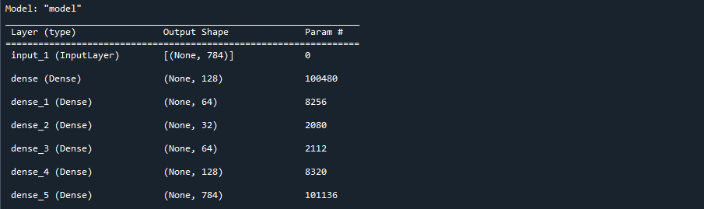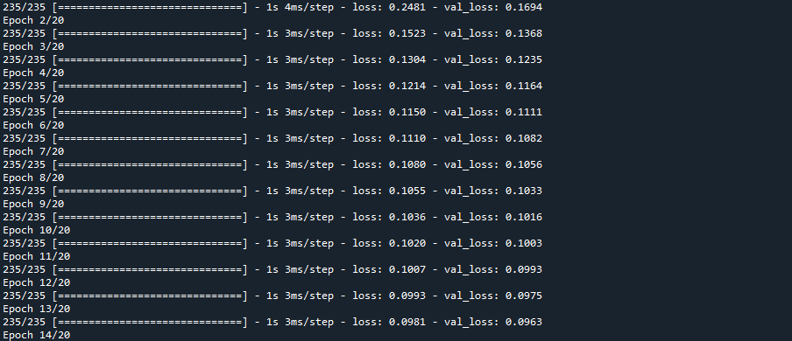
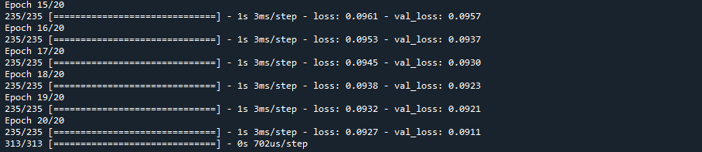
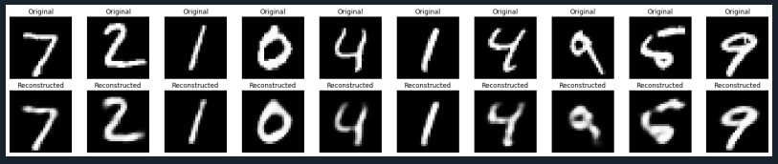

PRACTICAL NO – 09

Aim: Demonstrate Recurrent Neural Network that learns to perform sequence analysis for stock price. (google stock price)

Code:
# ----------------------------------
# Install Required Library
# ----------------------------------
!pip install yfinance --quiet

# ----------------------------------
# Import Required Libraries
# ----------------------------------
import yfinance as yf
import numpy as np
import pandas as pd
import matplotlib.pyplot as plt
import tensorflow as tf

from sklearn.preprocessing import MinMaxScaler
from tensorflow.keras.models import Sequential
from tensorflow.keras.layers import LSTM, Dense

print("TensorFlow version:", tf.__version__)

# ----------------------------------
# Download Google Stock Price Data
# ----------------------------------
ticker = 'GOOGL'
df = yf.download(ticker, start='2018-01-01', end='2024-12-31')

data = df[['Close']]
data.dropna(inplace=True)

# ----------------------------------
# Normalize Closing Price
# ----------------------------------
scaler = MinMaxScaler(feature_range=(0, 1))
scaled_data = scaler.fit_transform(data)

# ----------------------------------
# Create Sequences for LSTM
# ----------------------------------
sequence_length = 60
X, y = [], []

for i in range(sequence_length, len(scaled_data)):
X.append(scaled_data[i-sequence_length:i])
y.append(scaled_data[i])

X = np.array(X)
y = np.array(y)

# ----------------------------------
# Split Training and Testing Data
# ----------------------------------
train_size = int(len(X) * 0.8)

X_train = X[:train_size]
X_test = X[train_size:]

y_train = y[:train_size]
y_test = y[train_size:]

# ----------------------------------
# Build LSTM Model
# ----------------------------------
model = Sequential()

model.add(LSTM(50, return_sequences=True, input_shape=(X.shape[1], 1)))
model.add(LSTM(50))
model.add(Dense(1))

model.compile(optimizer='adam', loss='mean_squared_error')
model.summary()

# ----------------------------------
# Train the Model
# ----------------------------------
model.fit(
X_train,
y_train,
epochs=10,
batch_size=32,
validation_data=(X_test, y_test)
)

# ----------------------------------
# Predict and Inverse Transform
# ----------------------------------
predicted = model.predict(X_test)

predicted_prices = scaler.inverse_transform(predicted)
actual_prices = scaler.inverse_transform(y_test.reshape(-1, 1))

# ----------------------------------
# Plot Actual vs Predicted Prices
# ----------------------------------
plt.figure(figsize=(12, 6))

plt.plot(actual_prices, color='black', label='Actual Google Stock Price')
plt.plot(predicted_prices, color='green', label='Predicted Google Stock Price')

plt.title('Google Stock Price Prediction using RNN (LSTM)')
plt.xlabel('Time')
plt.ylabel('Price')
plt.legend()
plt.show()

Output:

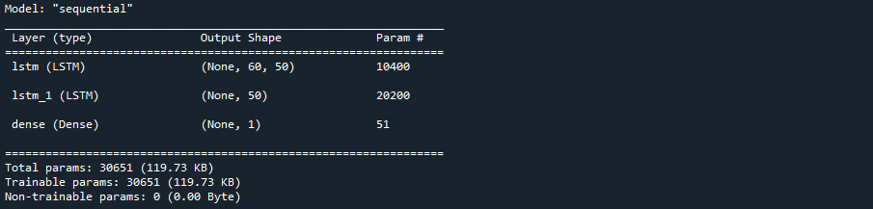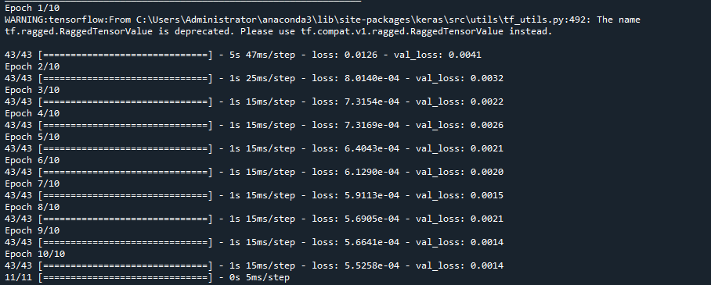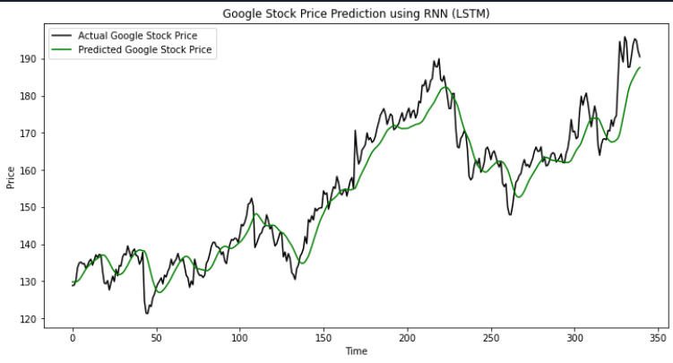

PRACTICAL NO – 10

Aim: Applying Generative Adversial Networks for image generation and unsupervised tasks.

Code:
# ----------------------------------
# Install & Import Required Libraries
# ----------------------------------
import numpy as np
import matplotlib.pyplot as plt
import tensorflow as tf

from tensorflow.keras.models import Sequential
from tensorflow.keras.layers import Dense, LeakyReLU, Reshape, Flatten
from tensorflow.keras.optimizers.legacy import Adam

print("TensorFlow version:", tf.__version__)

# ----------------------------------
# Load and Normalize MNIST Data
# ----------------------------------
(X_train, _), (_, _) = tf.keras.datasets.mnist.load_data()

X_train = X_train / 127.5 - 1.0 # Normalize to [-1, 1]
X_train = np.expand_dims(X_train, axis=-1)

# ----------------------------------
# Generator Model
# ----------------------------------
def build_generator():
model = Sequential()
model.add(Dense(128, input_dim=100))
model.add(LeakyReLU(0.2))
model.add(Dense(784, activation='tanh'))
model.add(Reshape((28, 28, 1)))
return model

# ----------------------------------
# Discriminator Model
# ----------------------------------
def build_discriminator():
model = Sequential()
model.add(Flatten(input_shape=(28, 28, 1)))
model.add(Dense(128))
model.add(LeakyReLU(0.2))
model.add(Dense(1, activation='sigmoid'))
return model

# ----------------------------------
# Compile Discriminator
# ----------------------------------
optimizer = Adam(learning_rate=0.0002, beta_1=0.5)

discriminator = build_discriminator()
discriminator.compile(
loss='binary_crossentropy',
optimizer=optimizer,
metrics=['accuracy']
)

# ----------------------------------
# Compile GAN
# ----------------------------------
generator = build_generator()
discriminator.trainable = False

z = tf.keras.Input(shape=(100,))
img = generator(z)
validity = discriminator(img)

gan = tf.keras.Model(z, validity)
gan.compile(loss='binary_crossentropy', optimizer=optimizer)

# ----------------------------------
# Training Loop
# ----------------------------------
def train_quick_gan(epochs=1000, batch_size=64):
half_batch = batch_size // 2

for epoch in range(epochs):

# Train Discriminator
idx = np.random.randint(0, X_train.shape[0], half_batch)
real_imgs = X_train[idx]

noise = np.random.normal(0, 1, (half_batch, 100))
fake_imgs = generator.predict(noise, verbose=0)

d_loss_real = discriminator.train_on_batch(
real_imgs, np.ones((half_batch, 1))
)
d_loss_fake = discriminator.train_on_batch(
fake_imgs, np.zeros((half_batch, 1))
)

d_loss = 0.5 * np.add(d_loss_real, d_loss_fake)

# Train Generator
noise = np.random.normal(0, 1, (batch_size, 100))
g_loss = gan.train_on_batch(noise, np.ones((batch_size, 1)))

# Print progress
if epoch % 250 == 0:
print(
f"{epoch} [D loss: {d_loss[0]:.4f}, acc: {100*d_loss[1]:.2f}%] "
f"[G loss: {g_loss:.4f}]"
)

# ----------------------------------
# Generate and Display Images
# ----------------------------------
def generate_and_show(generator, n=5):
noise = np.random.normal(0, 1, (n * n, 100))
gen_imgs = generator.predict(noise, verbose=0)

gen_imgs = 0.5 * gen_imgs + 0.5 # Rescale to [0,1]

fig, axs = plt.subplots(n, n, figsize=(5, 5))
count = 0
for i in range(n):
for j in range(n):
axs[i, j].imshow(gen_imgs[count, :, :, 0], cmap='gray')
axs[i, j].axis('off')
count += 1

plt.suptitle("Generated Digits")
plt.show()

# ----------------------------------
# Run Training
# ----------------------------------
train_quick_gan(epochs=1000, batch_size=64)

# ----------------------------------
# Show Generated Images
# ----------------------------------
generate_and_show(generator)

Output:
